FML UNIT 5

Clustering in Machine Learning
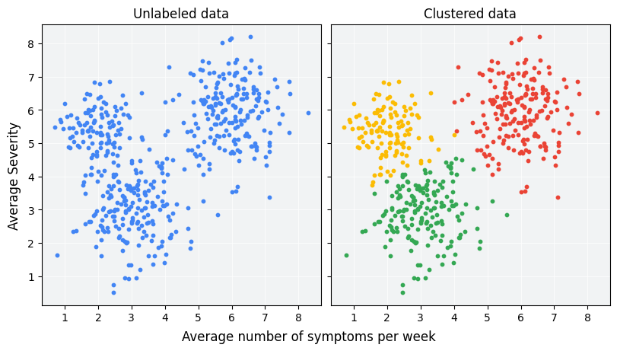
🔹 1. Concept and Goal
- Clustering is an unsupervised learning method used to group similar data points into clusters.
- It does not use labeled data — the algorithm learns patterns and similarities on its own.
- The goal is to ensure that:
  - Data points within a cluster are as similar as possible (high intra-cluster similarity).
  - Data points between clusters are as different as possible (low inter-cluster similarity).
👉 Example: Grouping customers based on their purchasing behavior (age, income, spending score, etc.).

🔹 2. Requirements of a Good Clustering Algorithm
A good clustering algorithm should have the following properties:
- Scalability
  - Should efficiently handle large datasets with many records and features.
  - Example: K-Means is scalable, while Hierarchical Clustering struggles with large data.
- Interpretability
  - The output (clusters) should be easy to understand and explain.
  - For instance, clusters representing "high-value customers" should make sense in business terms.
- Handling Noise and Outliers
  - Real-world data contains errors or exceptional points; good algorithms can ignore or minimize their effect.
  - Example: DBSCAN handles noise well.
- Flexibility and Adaptability
  - Should work with different types of data (numeric, categorical) and cluster shapes (spherical, arbitrary).
- High Dimensional Capability
  - Should perform well when the dataset has many attributes (features).
- Minimal Parameter Requirement
  - Fewer input parameters make algorithms easier to use and less sensitive to tuning.

🔹 3. Types of Clustering
(a) Partition-based Clustering
- Divides the dataset into a fixed number of clusters, usually k.
- Each data point belongs to exactly one cluster.
- The objective is to minimize intra-cluster distance and maximize inter-cluster distance.
- Example: K-Means Algorithm
  - Works by finding k centroids and assigning each point to the nearest centroid.
  - Iteratively updates centroids until they stabilize.
  - Simple and efficient but needs k beforehand and struggles with non-spherical data.

(b) Density-based Clustering
- Forms clusters based on areas where data points are densely packed together.
- Points in low-density regions are treated as noise or outliers.
- Example: DBSCAN (Density-Based Spatial Clustering of Applications with Noise)
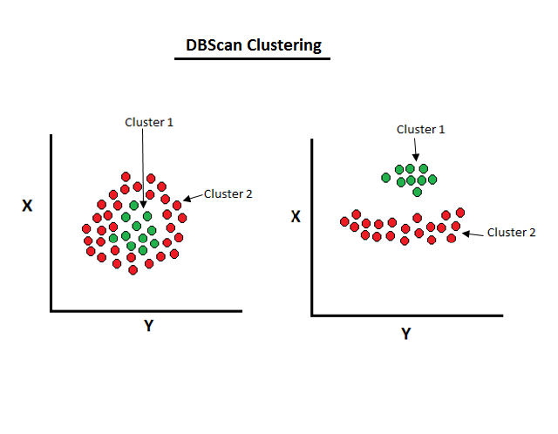
  - Defines clusters as regions with high density separated by low-density areas.
  - Can find clusters of any shape and handle noise well.
  - However, parameter tuning (Eps and MinPts) is critical.

(c) Hierarchical Clustering
- Builds a tree-like structure (dendrogram) of clusters.
- Two main types:
  - Agglomerative (bottom-up):
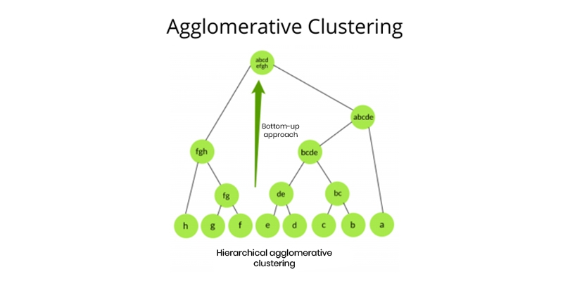
    - Each point starts as a separate cluster.
    - Pairs of clusters are merged step-by-step based on similarity until one large cluster remains.
  - Divisive (top-down):
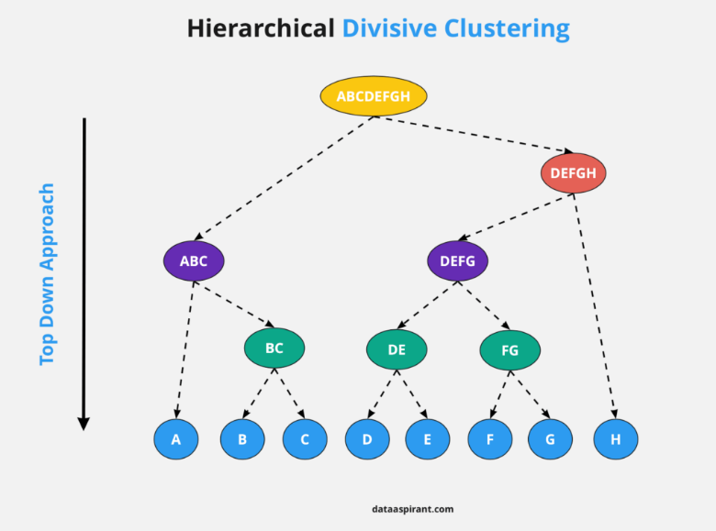
    - Starts with one large cluster and divides it into smaller clusters.
    - No need to predefine the number of clusters; can cut the dendrogram at desired level.
    - Drawback: computationally expensive for large datasets.

(d) Model-based Clustering
- Assumes data is generated from a mixture of underlying probability distributions (models).
- Each cluster is represented by a distribution, and the algorithm estimates parameters of these models.
- Example: Gaussian Mixture Model (GMM)
  - Uses the Expectation-Maximization (EM) algorithm to find parameters.
  - Provides soft clustering (a point can belong to multiple clusters with certain probabilities).
  - More flexible than K-Means but computationally intensive.

🔹 4. Distance Measures in Clustering
Used to measure similarity (or dissimilarity) between data points.
Commonly used metrics:
Measure | Formula / Idea | When to Use
Euclidean Distance | Straight-line distance between two points | When scale of features is similar
Manhattan Distance | Sum of absolute differences | For grid-like data (e.g., city blocks)
Cosine Similarity | Measures angle between two vectors | When direction matters more than magnitude (e.g., text data)

🔹 5. Applications of Clustering
- Market Segmentation – Grouping customers by behavior or preferences.
- Image Segmentation – Dividing an image into regions of similar color or texture.
- Document or Topic Clustering – Grouping news articles, research papers, or web pages.
- Anomaly Detection – Detecting unusual behavior like fraud or system failures.
- Social Network Analysis – Identifying communities within large networks.
- Recommender Systems – Grouping similar users or products for recommendations.

🔹 6. Comparison Among Clustering Types
Type | Example | Advantages | Disadvantages
Partition-based | K-Means | Simple, fast, scalable | Needs k, sensitive to outliers
Density-based | DBSCAN | Detects arbitrary shapes, handles noise | Struggles with varying densities
Hierarchical | Agglomerative | No need to specify k, gives hierarchy | Computationally expensive
Model-based | GMM | Handles complex distributions, soft clustering | Needs high computation and tuning

🔹 7. Important Exam Questions & Answers
Q1. Which clustering algorithm is based on centroids?
→ K-Means Algorithm
Q2. What is the goal of clustering?
→ To group similar data points together and separate dissimilar ones.
Q3. Requirements of a good clustering algorithm?
→ Scalability, interpretability, noise handling, flexibility, high-dimensional capability.
Q4. Write a short note on Clustering.
→ Clustering is an unsupervised learning technique that groups data into clusters based on similarity. It is used for data pattern discovery and segmentation. Common types include K-Means, DBSCAN, and Hierarchical Clustering.
Q5. What is Gaussian Mixture Model (GMM)?
→ GMM is a model-based clustering method that assumes data points are generated from a mixture of multiple Gaussian distributions. It uses the Expectation-Maximization (EM) algorithm to estimate cluster parameters.
Applications: Image segmentation, speaker recognition, and anomaly detection.

Gaussian Mixture Models (GMM)
🔹 1. Concept of GMM
- Gaussian Mixture Model (GMM) is a probabilistic model used for clustering and density estimation.
- It assumes that the data is generated from a mixture of several Gaussian (Normal) distributions, each representing a cluster.
- Unlike K-Means, which assigns each point to one cluster (hard clustering), GMM provides soft clustering, meaning each point has a probability of belonging to every cluster.
👉 Example Idea:
Imagine data points forming two overlapping groups — GMM can assign probabilities like:
- Point A: 80% chance of being in Cluster 1, 20% in Cluster 2
- Point B: 60% in Cluster 1, 40% in Cluster 2
This makes GMM more flexible and suitable for real-world, overlapping data.

🔹 2. Mixture of Multiple Gaussian Distributions
- GMM combines multiple Gaussian (bell-curve shaped) distributions.
- Each Gaussian represents one cluster and is defined by two parameters:
  - Mean (μ): Center of the cluster
  - Covariance (Σ): Spread or shape of the cluster
- The model also includes mixing coefficients (π) that indicate the proportion of each cluster in the total data.
Mathematically,
$$P\left(x\right)=\sum_{k=1}^{k}{π_{k}}⋅N\left(\left.x\right|μ_{k},Σ_{k}\right)$$where:
- ( K ) = number of Gaussian components (clusters)
- ( \pi_k ) = weight of each Gaussian (sum of all π = 1)
- ( N(x | \mu_k, \Sigma_k) ) = Gaussian probability density function

🔹 3. Expectation-Maximization (EM) Algorithm for GMM
Since we don’t know which data point belongs to which Gaussian, we use the EM algorithm to estimate parameters.
Steps of EM Algorithm:
- Initialization:
  - Start with random guesses for means (μ), covariances (Σ), and mixing coefficients (π).
- E-Step (Expectation):
  - Calculate the probability (responsibility) that each data point belongs to each cluster using current parameters.
  - Formula:
$$r_{ik}=\frac{π_{k}⋅N\left(\left.x_{i}\right|μ_{k},Σ_{k}\right)}{Σ_{j=1}^{k}π_{j}⋅N\left(\left.x_{i}\right|μ_{j},Σ_{j}\right)}$$Here, ( r_{ik} ) = probability that data point ( i ) belongs to cluster ( k ).
- M-Step (Maximization):
  - Update the parameters (μ, Σ, π) based on these probabilities.
  - New means, covariances, and weights are computed to maximize the likelihood of the data.
- Repeat:
  - Continue E and M steps until parameters stabilize (convergence).
✅ Output: The model now knows the Gaussian parameters that best fit the data distribution.

🔹 4. Soft Clustering vs Hard Clustering
Feature | Hard Clustering (K-Means) | Soft Clustering (GMM)
Assignment | Each point belongs to exactly one cluster | Each point has a probability of belonging to multiple clusters
Boundary | Sharp and well-defined | Overlapping and flexible
Shape of Cluster | Spherical only | Elliptical (due to covariance)
Use Case | Simple, distinct clusters | Overlapping or probabilistic data

🔹 5. Relationship Between GMM and K-Means
- K-Means can be seen as a special case of GMM when:
  - Covariance matrices are spherical and identical for all clusters.
  - Hard assignments are made (probabilities are either 0 or 1).
- In short:
  - K-Means → deterministic, simpler
  - GMM → probabilistic, more flexible and powerful

🔹 6. Real-world Applications of GMM
- Image Segmentation – Divides an image into regions based on color intensity.
- Speaker Identification – Models different voice patterns in speech recognition.
- Anomaly Detection – Detects abnormal patterns in financial transactions or sensor data.
- Clustering Complex Data – Useful when clusters overlap or have different shapes.
- Density Estimation – Estimates the probability distribution of data for sampling or simulation.

🔹 7. Example
Let’s say we have height data of two mixed populations (men and women).
- The overall height distribution looks like two overlapping bell curves.
- GMM can model this as a mixture of two Gaussian distributions, each representing one group.
- Instead of drawing a strict boundary, GMM gives probabilities for each person’s height belonging to either group.

❓ Exam-Oriented Questions
Q1. Explain the concept of Gaussian Mixture Models (GMM) and their applications.
→ GMM is a probabilistic clustering technique that represents data as a combination of multiple Gaussian distributions. Each distribution defines one cluster, and the EM algorithm estimates model parameters. GMM performs soft clustering and is used in speech recognition, anomaly detection, and image segmentation.

Q2. What is Gaussian Mixture Model? Explain with an example.
→ GMM assumes data points are generated from multiple Gaussian distributions. For example, if height data of men and women overlap, GMM models it as two Gaussian components, each representing one group, and estimates the probability that a person belongs to each.

Q3. What is clustering in ML? Explain GMM and its applications.
→ Clustering groups similar data points together. GMM performs probabilistic (soft) clustering using multiple Gaussian distributions and the EM algorithm. Applications include speaker recognition, density estimation, and medical image analysis.

Spectral Clustering
🔹 1. Concept and Intuition
- Spectral Clustering is an unsupervised learning method used to group data points based on their similarity.
- It is particularly useful when clusters are non-linear or non-spherical (i.e., not clearly separated like circles or blobs).
- Instead of working directly with the data’s coordinates, Spectral Clustering works with a similarity graph — it focuses on how points are connected or related to each other.
- The idea is to transform data into a low-dimensional space using eigenvectors (from linear algebra) and then apply a simple clustering algorithm (like K-Means) in that transformed space.
👉 In simple words:
Spectral Clustering converts complex-shaped data into a form where it becomes easier to separate clusters using K-Means or similar methods.

🔹 2. Steps Involved in Spectral Clustering
Step 1: Construct a Similarity Graph
- Each data point is treated as a node in a graph.
- Edges connect nodes that are similar or close to each other.
- The weight of the edge shows how similar two nodes are (using a similarity measure like Euclidean distance or Gaussian kernel).
Common graph types:
- ε-neighbourhood graph: Connect points within a distance ε.
- k-nearest neighbour graph: Connect each point to its k closest neighbours.
- Fully connected graph: Connect every pair with weights based on distance.

Step 2: Compute the Graph Laplacian Matrix
- From the similarity graph, a Laplacian matrix (L) is created to represent connections.
- Formula:
L = D - W
where
  - W = similarity (weight) matrix
  - D = diagonal degree matrix (sum of weights connected to each node)
- The Laplacian captures how connected or separate the data points are.

Step 3: Eigen Decomposition
- Compute the eigenvalues and eigenvectors of the Laplacian matrix.
- These eigenvectors capture the structure of the graph, showing how data points are related in a reduced (simpler) form.
- Select the top k eigenvectors corresponding to the k smallest eigenvalues (for k clusters).

Step 4: Cluster the Eigenvectors
- Treat each row of the selected eigenvectors as a new data point in a lower-dimensional space.
- Apply K-Means (or another simple clustering algorithm) on these new points to form k clusters.
✅ Final result: Data points are grouped into k meaningful clusters based on their graph structure rather than just their raw coordinates.

🔹 3. Advantages of Spectral Clustering
- Handles complex shapes: Can cluster data that forms non-spherical or non-linear shapes, unlike K-Means.
- Uses graph theory: Works well even when the data does not lie in a continuous geometric space.
- No strict distribution assumption: Doesn’t assume clusters are Gaussian or circular.
- Good with small datasets: Performs well even when data size is not huge.
- Flexible similarity measure: Can use different ways to define “similarity,” making it versatile.

🔹 4. When to Use Spectral Clustering
- When clusters are not clearly separable by straight lines or spherical boundaries.
- When data points are connected by relationships rather than simple geometric distance.
- When using graph-based data, like social networks or image segments.
- When you want to find clusters that follow a manifold or curve (non-linear structure).

🔹 5. Comparison with K-Means
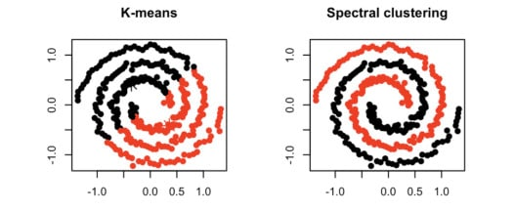
Feature | K-Means | Spectral Clustering
Data type | Works well for circular clusters | Works for non-linear, irregular shapes
Approach | Uses Euclidean distance directly | Uses graph and eigenvectors
Limitation | Fails for complex data | Handles complex shapes easily
Example | Separates spherical blobs | Can separate ring or spiral shapes

🔹 6. Example (Intuitive)
Imagine data points forming two interlocked rings.
- K-Means would fail because both rings are close in Euclidean distance.
- Spectral Clustering, however, looks at connectivity rather than direct distance — it separates each ring correctly into its own cluster.

❓ Exam Question
Q1. Describe the spectral clustering algorithm and its advantages.
✅ Answer (Exam-Ready):
Spectral Clustering is a graph-based clustering method that groups data points using similarity information rather than direct distance.
It follows these main steps:
- Construct a similarity graph between points.
- Compute the Laplacian matrix.
- Perform eigen decomposition to find top eigenvectors.
- Apply K-Means on these eigenvectors to form clusters.
It is advantageous because it can detect non-linear and complex-shaped clusters, does not assume data distribution, and is more flexible than K-Means for real-world datasets like image segmentation or social network analysis.

** DO ENSEMBLE METHODS FROM UNIT 4

Learning Theory (Introduction)
🔹 1. Concept of Learning Theory
- Learning Theory explains how machines learn from data and how well a model can generalize from training data to unseen data.
- It focuses on the relationship between model complexity, training data, and prediction accuracy.
- The main goal is to create models that perform well on new, unseen data, not just memorize the training data.

🔹 2. Bias-Variance Trade-off
- This trade-off helps explain the balance between underfitting and overfitting.
  - High Bias: Model is too simple → underfits data → poor accuracy.
  - High Variance: Model is too complex → overfits data → performs well on training data but poorly on test data.
- A good model maintains a balance between bias and variance to achieve high generalization accuracy.

🔹 3. Overfitting and Underfitting
- Overfitting: The model memorizes training data (too complex). It performs well on training data but poorly on new data.
- Underfitting: The model is too simple to capture patterns in data (too high bias).
- The goal is to find a sweet spot between these extremes using techniques like regularization or cross-validation.

🔹 4. PAC (Probably Approximately Correct) Learning – Basic Idea
- PAC learning is a theoretical framework that defines what it means for a model to learn successfully.
- A model is PAC-learnable if it can, with high probability, find a hypothesis that is approximately correct (close to true function) using a finite number of training examples.
- In short:
  - “Probably” = high probability of being correct.
  - “Approximately Correct” = small allowable error.

🔹 5. Generalization Error and Performance Evaluation
- Generalization error is the difference between a model’s performance on training data and unseen data.
- Low generalization error means the model learned real patterns, not noise.
- It is evaluated using test datasets or cross-validation methods.

🔹 6. Connection with Ensemble and Reinforcement Learning
- Ensemble Learning: Reduces generalization error by combining multiple models (balances bias and variance).
- Reinforcement Learning: Uses learning theory to improve decision-making through repeated trials and feedback, minimizing error over time.

🧠 In Short:
Learning Theory helps understand why and how models learn, ensuring they generalize well to unseen data by managing bias, variance, and errors.
It forms the foundation for advanced topics like ensemble learning, reinforcement learning, and model evaluation.

Reinforcement Learning
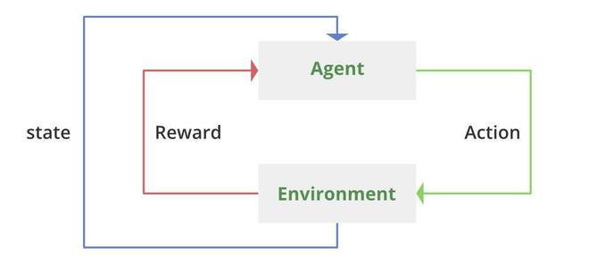
Concept of Reinforcement Learning (RL):
Reinforcement Learning is a type of machine learning where an agent learns to make decisions by interacting with an environment to achieve a goal. Unlike supervised learning, RL doesn’t learn from labeled data — instead, it learns through trial and error, receiving rewards or penalties based on its actions. The objective is to find a policy that maximizes the total cumulative reward over time.

🔹 Key Components of RL
- Agent:
The learner or decision-maker that performs actions in the environment.
Example: A robot navigating a maze.
- Environment:
The external system with which the agent interacts. It provides feedback in the form of states and rewards.
Example: The maze in which the robot moves.
- State (s):
A representation of the current situation or condition of the environment.
Example: The robot’s current location in the maze.
- Action (a):
A set of possible moves or decisions the agent can make.
Example: Move left, right, forward, or backward.
- Reward (r):
Feedback from the environment after performing an action. Positive rewards encourage desired behavior, while negative rewards discourage poor actions.
Example: +10 for reaching the goal, -1 for hitting a wall.

🔹 Policy and Value Functions
- Policy (π):
A mapping from states to actions — it defines how the agent behaves in a given state.
  - Deterministic Policy: Always chooses the same action for a state.
  - Stochastic Policy: Chooses actions based on probability.
- Value Function:
Measures the expected cumulative reward from a state (or state-action pair) following a policy.
  - State Value (V(s)): Expected reward starting from state s.
  - Action Value (Q(s, a)): Expected reward taking action a in state s and then following policy π.

🔹 Exploration vs. Exploitation
- Exploration: Trying new actions to discover better rewards.
- Exploitation: Using known information to maximize immediate reward.
RL algorithms balance both — too much exploitation may miss better actions, while too much exploration slows learning.

🔹 Examples of RL Applications
- Game Playing: AlphaGo, Chess, or Atari agents.
- Robotics: Path planning and motion control.
- Recommendation Systems: Personalized content delivery.
- Autonomous Vehicles: Learning driving strategies from environment feedback.

❓ Question:
Define reinforcement learning and describe its main components.
Answer:
Reinforcement Learning is a goal-oriented learning approach where an agent interacts with an environment by performing actions and receiving rewards or penalties as feedback. It aims to learn an optimal policy that maximizes cumulative rewards. The main components of RL are:
- Agent: Learner/decision-maker
- Environment: System interacted with
- State: Current situation
- Action: Choice made by the agent
- Reward: Feedback from the environment
It also involves balancing exploration and exploitation to learn effectively.

** DO HYPOTHESIS TESTING FROM UNIT 4

